EventHub Requirements Specification
1.0 Product Overview
EventHub is a web application that provides a place for members to organize and explore local events that interest them. An event on EventHub can be anything from a pickup football game to a nationally touring concert coming to your town. More specifically, EventHub empowers users to manage a personal account that includes creating and deleting events, following other members, and the ability to RSVP to events. EventHub also provides robust mechanisms which give users the ability to discover events around them. These mechanisms include an “event feed” view where all upcoming events can be seen. Also users have the ability to search events based on various parameters including date, type, and location. Finally users have the ability to follow other users' event creation. All of these features are provided via a reliable and robust back-end that provides enterprise-level reliability without compromising in flexibility. The software that runs EventHub has been battle tested in production environments for years on the largest of scales. Through all the powerful features that EventHub provides, the software breaks down the existing barriers that are in place for people to find events and meaningful experiences around them. No longer will a person be disappointed when they find out about a concert only after it happened or be frustrated when they did no hear about a pickup basketball game happening with some friends she hasn't been able to catch up with in a long time. No matter what the event though the key mission of EventHub remains the same: Help people find exciting, meaningful, and interesting things to do wherever they may find themselves.
2.0 Information Description
2.1 – User Interface
See User Manaul section of software configuration.
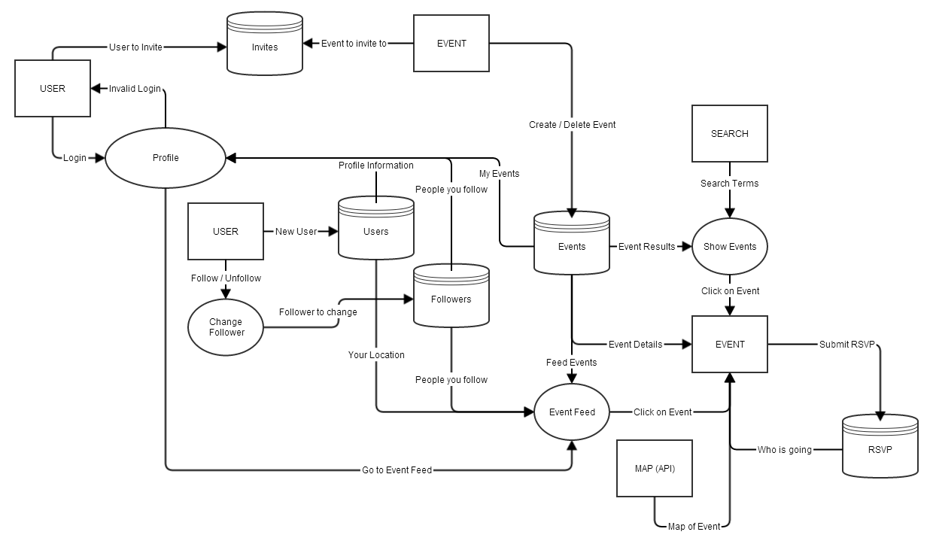
2.2 – High Level Data Flow Diagram
3.0 Functional Descriptions
3.1 New User
3.1.1 Description:
3.1.2 IC Cards:
3.1.3 Design Constraints:
3.2 Follow Other User
3.2.1 Description:
3.2.2 IC Cards:
3.2.3 Design Constraints:
3.3 Event Creation
3.3.1 Description:
3.3.2 IC Cards:
3.3.3 Design Constraints:
3.4 Event Deletion
3.4.1 Description:
3.4.2 IC Cards:
3.4.3 Design Constraints:
3.5 Event Search
3.5.1 Description:
3.5.2 IC Cards:
3.5.3 Design Constraints:
3.6 RSVP to an Event
3.6.1 Description:
3.6.2 IC Cards:
3.6.3 Design Constraints:
3.7 View Event Feed
3.7.1 Description:
3.7.2 IC Cards:
3.7.3 Design Constraints:
3.8 Invite User to Event
3.8.1 Description:
3.8.2 IC Cards:
3.8.3 Design Constraints:
3.9 Event Map
3.9.1 Description:
3.9.2 IC Cards:
3.9.3 Design Constraints:

